Mr. Pok Kosal 31 years old, Paraplegia
He ‘s got his small business with repairing(TV, radio ,tape player…)

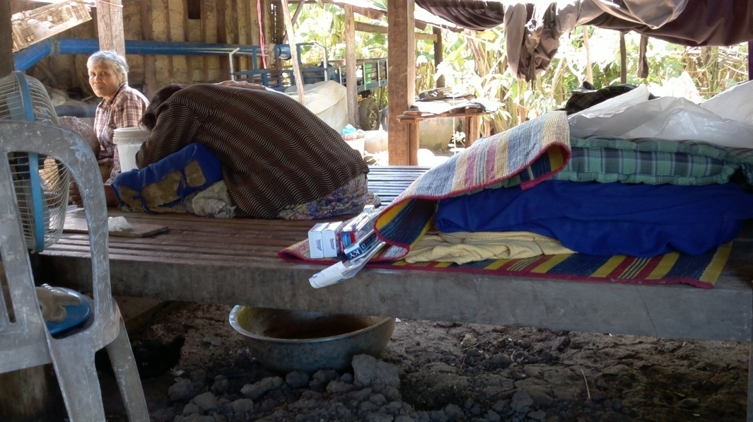
Ms. Yim Phoeurrn 46 years old ,paraplegia
She ‘s got mental problem ,can not do concentration she lean on her legs,
She sits on the hole of the bed above the metal basin for urine leak during the day.
Economic issue

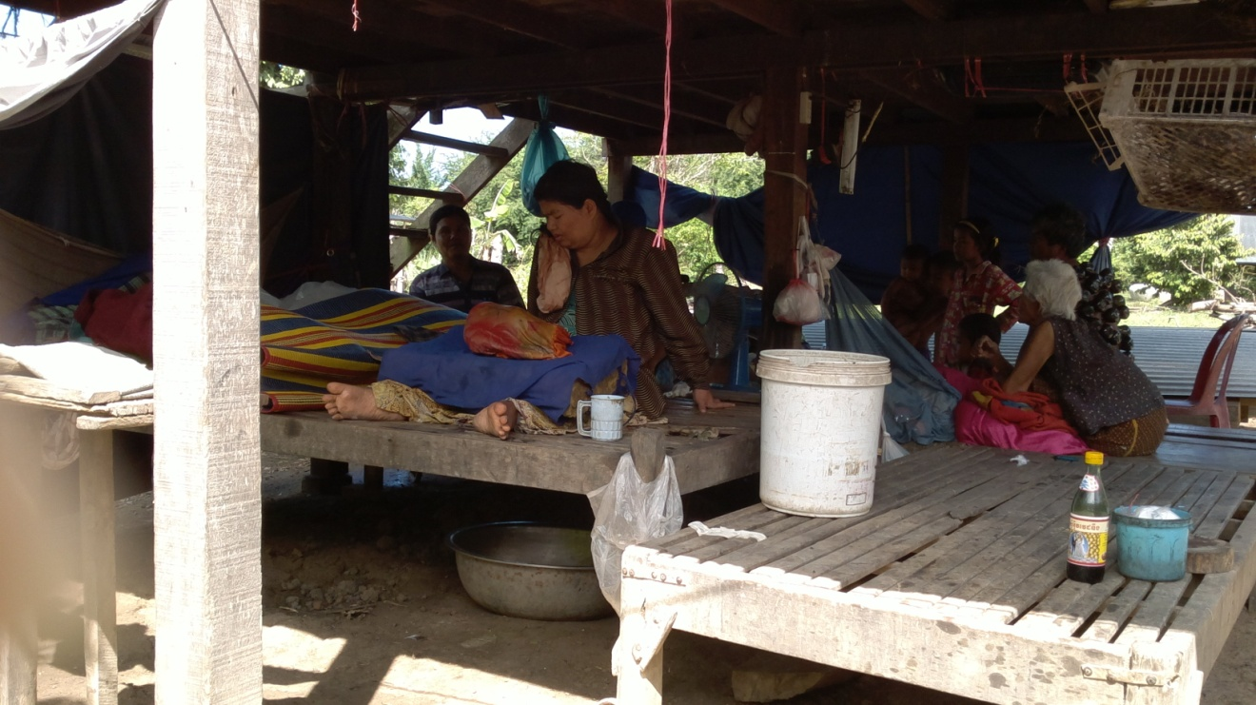

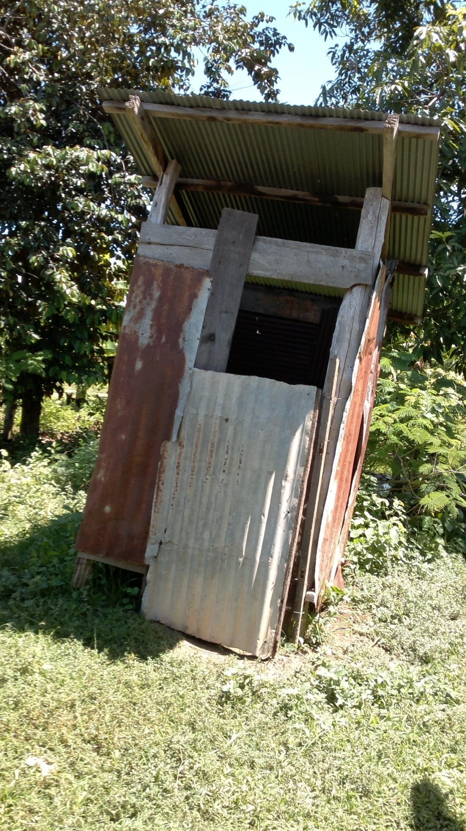
No adapted toilet

Mrs You Tharin 44 years old, paraplegia
She stays inside her mosquito net

Mrs Muth Loeur 73 years old , tetraplegia
-Pain
Economic issue

Mr. Korng Samruoch 57 years old , paraplegia
He’s got chronic pressure ulcers on both ischions grade 4, one on sacrum
The mattress is old , the seating cushion
The front castor of his wheelchair is broken (small)
-pain
Economic issue

