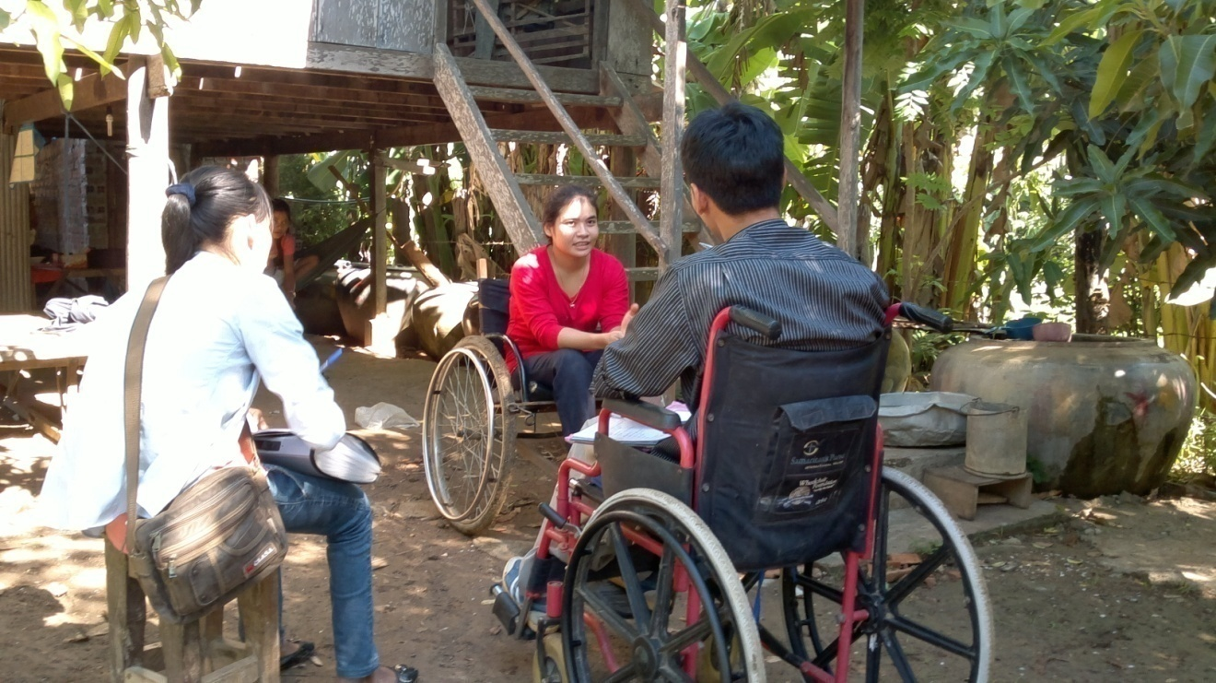

Miss Sorn Sarong, 22 years old paraplegia incomplete
She ‘s always at home and not confident and safe to go out
Unemployment
She feels happy with our visit

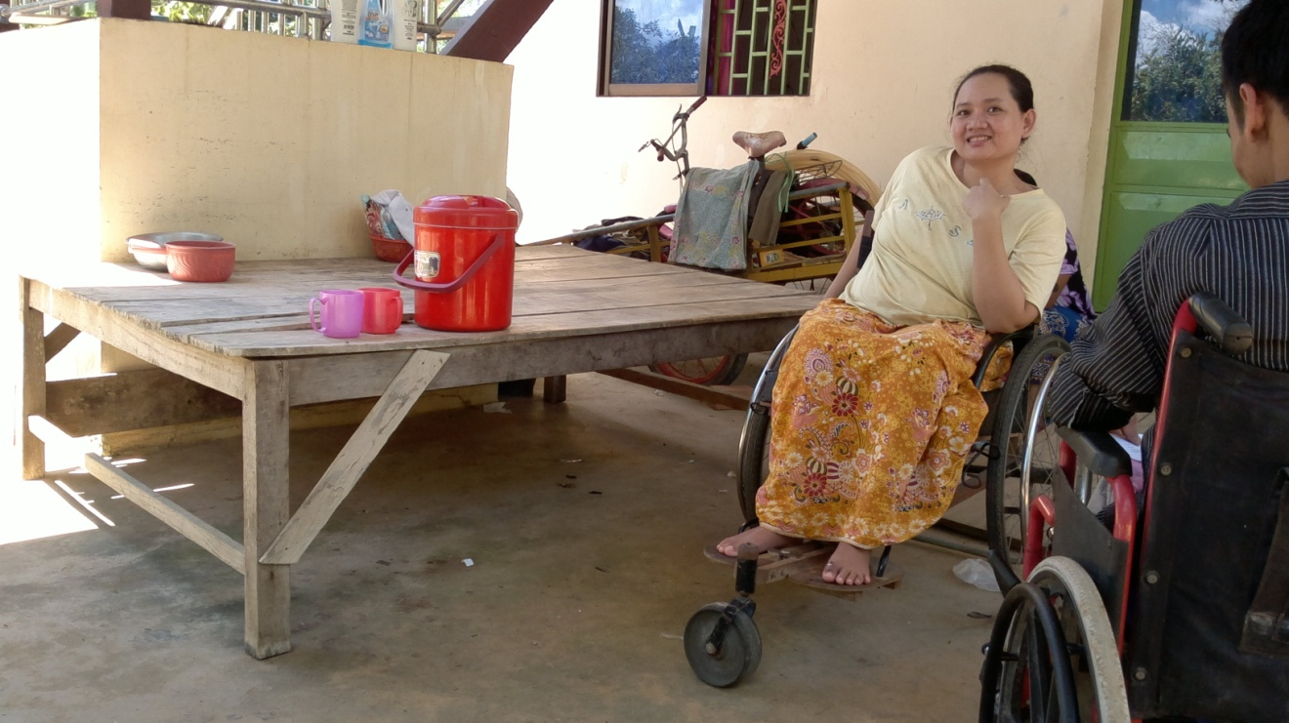
Ms. Pov Sina 27 years old, ,paraplegia incomplete
She takes a bath on that bed at night
Because there’s no enclosure
She wants to go out but difficult in transferring ,she needs assistance n transferring

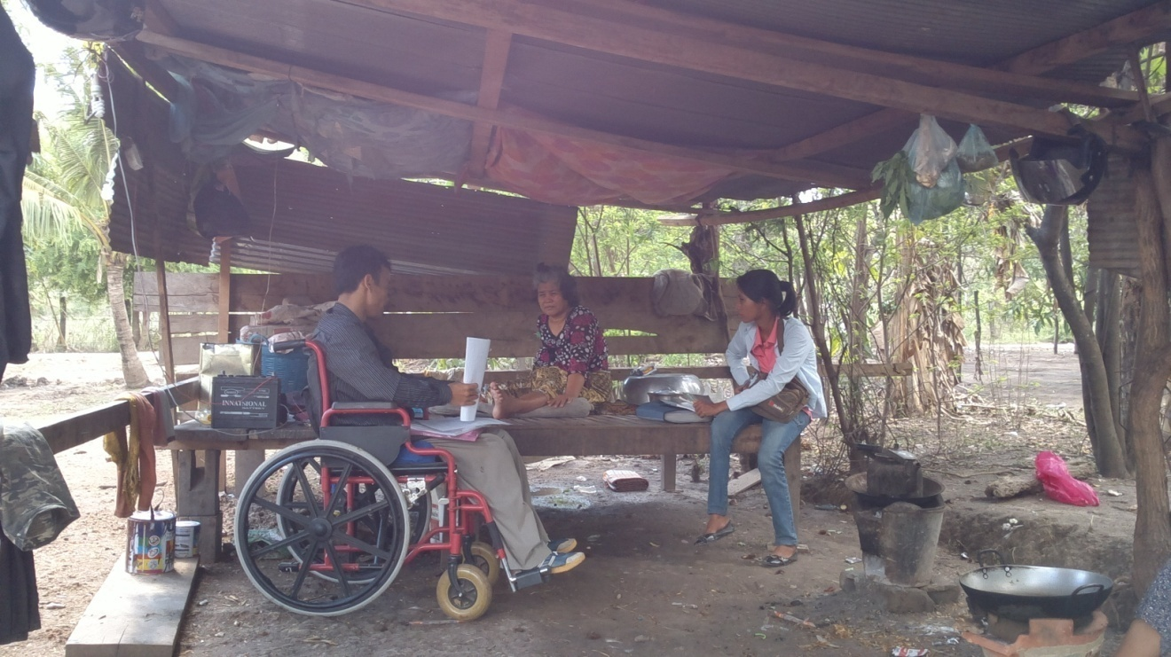

Mrs. Noem Nim 55 years old paraplegia
Her bed , bathroom and toilet on that bed
Isolation
Economic
Mattress
Cushion

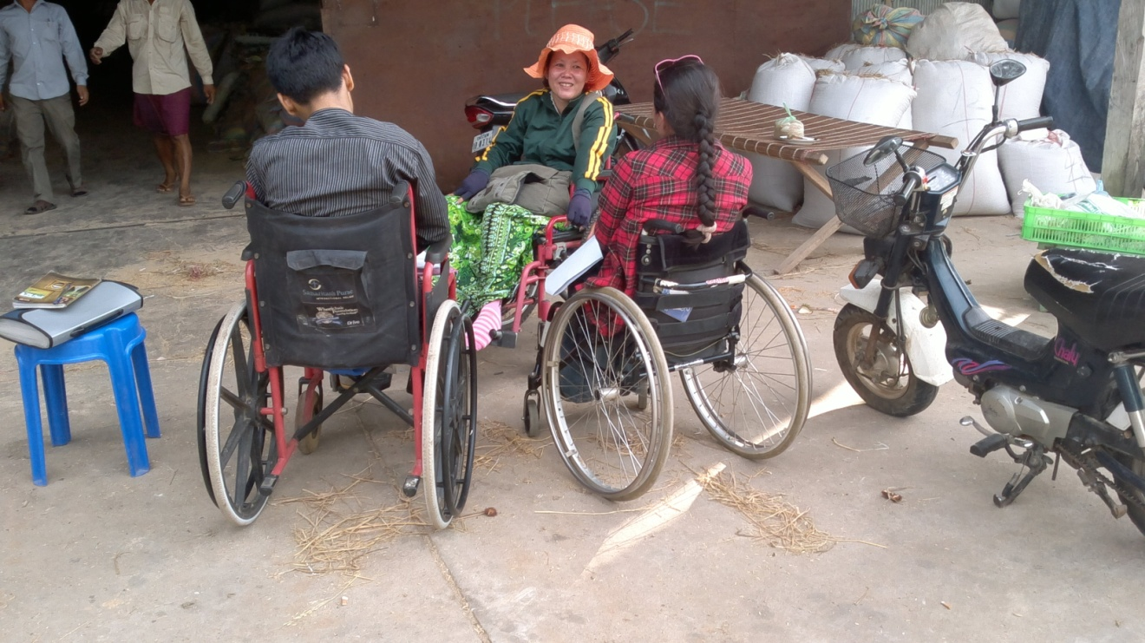

Mrs Ley Channy 37 years old , paraplegia
She feels happy with our visit

