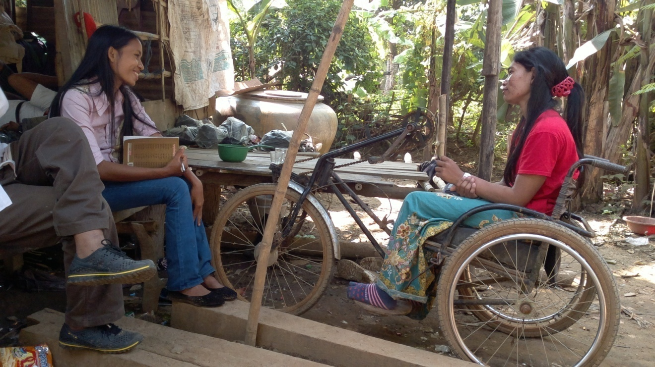

Mrs Roeurn Sarom 33 years old, Paraplegia
It’s the day that she discharged from district health center
She’s always got abdominal pain

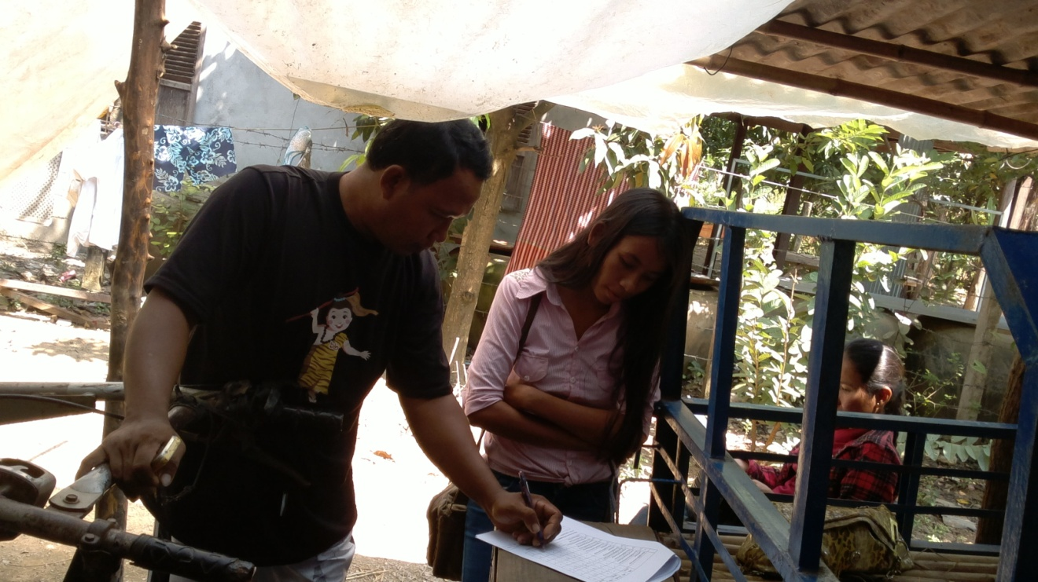

Mr. Phei Sophal 42 years old, paraplegia incomplete
He’s fallen from Tamarin tree
He’s shared information filling WHO questionnaire form

Miss Loeurm Luoth 42 years old paraplegia incomplete
I have informed her about participation in training peer support project
She’s said she like that very much but she feels too much afraid of going out
After the clash on her head she’s got much pain on her head
When she goes out taking moto rtaxi or Tuktuk . it’s bumpy so she when she’s back home
She’s got too much headache and swollen her face

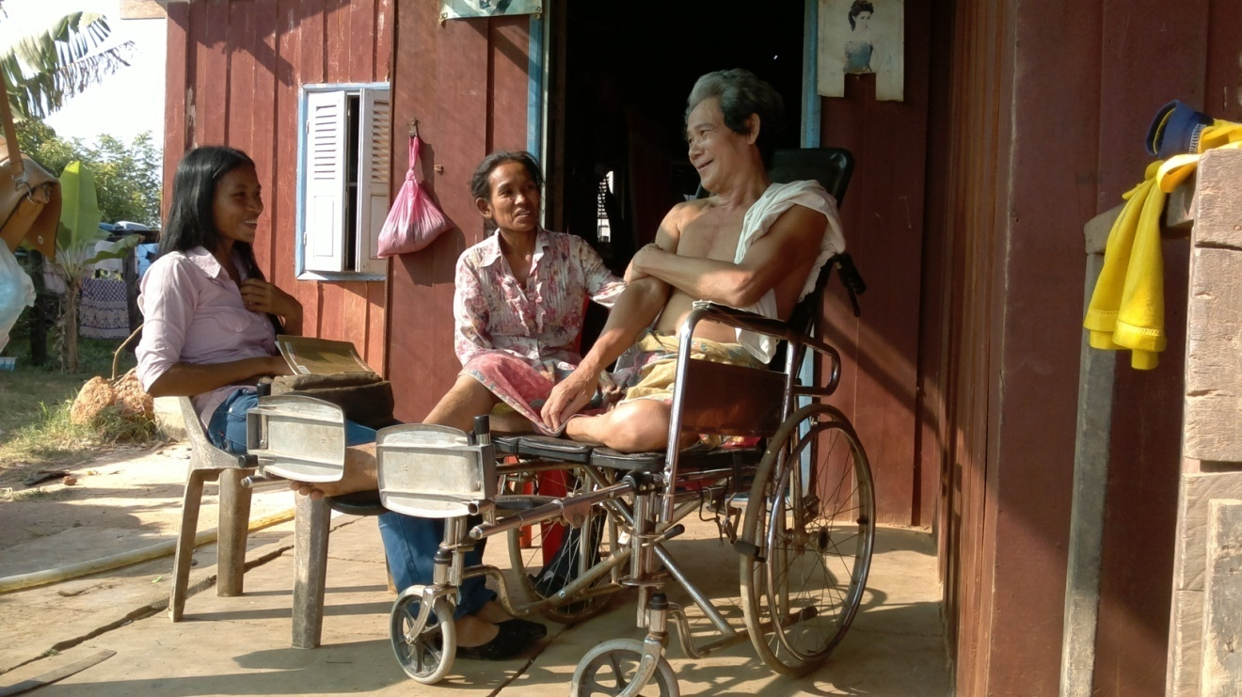

Mr Meas Horn 60 years old paraplegia , falling from hose
H’s got bladder stone ,pain
He’s never gone to heath center since discharge from SCI center
The family’s bought medicine from pharmacy . Now he’s got stomach problem
He’s suggested us what’s the medicine he got at SCI center
We are thinking of them he’s never gone to health center since discharge

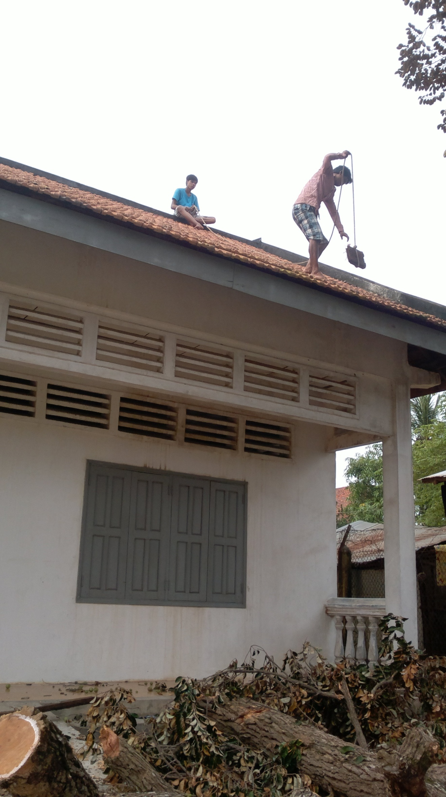
The branches of the tree falling on the roof
Repairing a few of roof bricks are broken and it leaks when rain comes

